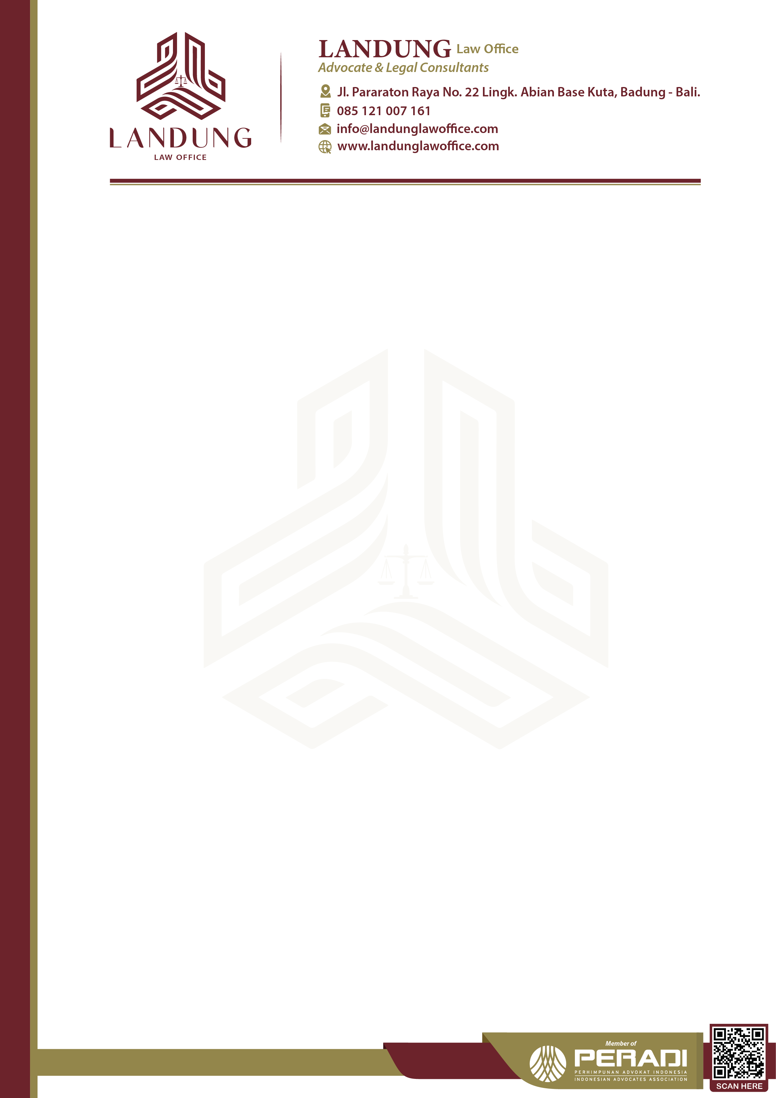

Petunjuk :

* Harap rangkum secara rinci situasi yang ingin Anda konsultasikan.
* Beri tahu kami dokumen pendukung apa yang Anda miliki terkait kondisi Anda.
* Setelah selesai, silakan kirim melalui WhatsApp/email.

Konsultan kami akan menilai situasi Anda berdasarkan ringkasan Anda dan mengirimkan penawaran harga untuk layanan kami. Terima Kasih.

Instruction:

* Please summarize in detail the situation you would like to consult.
* Let us know what supporting documents you have related to your condition.
* Upon completion, please send this via WhatsApp / email.

Our consultant will assess your situation based on your summary and send you the quotation for our service. Thank You.

Ketik di sini…